Intro to JavaScript Week 5 Coding Assignment

**Screenshots of Code:**

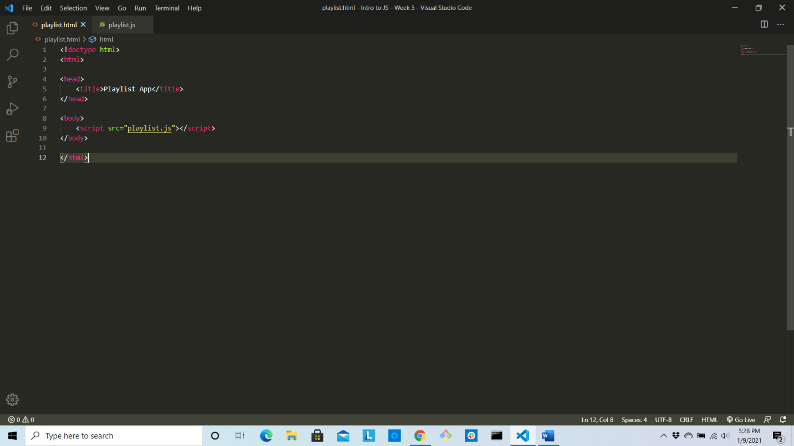

**Screenshots of Running Application:**

